Deans Mill School Spirit Days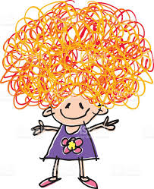
2019-2020

September 20: Wear Green and White or your DMS apparel

October 25: Crazy Hair Day

November 27: Stonington Bears Day. Wear Brown & White

December 20: Holiday Cheer Day. Wear your favorite holiday apparel

January 10: Hawaiian Day.

January 31: Team Day. Wear your favorite jersey or clothing from your favorite sports team for the Super Bowl

February 21: Flannel Friday. Wear a flannel shirt or clothing

March 6: Wear a Shirt with Words Day for Read Across America Week

March 20: Wear Yellow for Downs Syndrome Awareness

April 2: Light it Up Blue for Autism Awareness. Wear blue clothing.

April 24: Animal Day. Wear a shirt or clothing with an animal print.

May 22: America Day. Wear Patriotic clothing or red, white, and blue.
